**Specification Document-**

**Weather Balloon**

**-:Mentor:-**

Ritik Raj

Vishesh

Prathamesh Bhaktan

**-:Team:-**

Pragyansh Chaturvedi

Ashutosh Singh

Chaitany Raghav

Harshit Gupta

Tushar Gupta

**Github Repository Link:-** https://github.com/PragChat/weather_balloon

**-:Problem Statement:-**

Gathering Air quality index data at different locations and altitudes of the atmosphere and use it to monitor air quality at a location in a cost effective way.

**Objective**

To create a low cost helium-filled weather balloon loaded with an Arduino Uno Board and sensors of high specificity along with gps and altitude monitoring modules.

**-:Components Required:-**

Arduino Uno

Breadboard

Jumper wires

GPS GSM 808 module

SD card module

BME680 sensor

MICS2714 sensor

DSM501A sensor

MQ131 sensor

2200 mAh LiPo Batteries

A 3D printed casing

Latex Balloon

DC motor with propeller and DC motor driver

**-:Final Goals of project:-**

1. Achieving a height of 10000ft

2. Monitor Ozone, NOx, CO, VOC and Particulate Matter levels

3. Write this data on the SD card

4. Send us coordinates and altitude using the GSM module so we can track the balloon.

**-:Component overview and choice reasoning:-**

**2200 mAh LiPo battery**

We are using a LiPo battery as alkaline batteries will freeze up in the low temperatures at higher altitudes. 2200mAh would enough for the balloon to last half a day. We haven’t experimented how long the battery would last. After doing a test we can accordingly increase the capacity. Also, we have to keep in mind that battery life gets reduced at low temperatures.

**-:3D Printed Casing:-**

Since the electronics can’t withstand very low temperature, we will be making A UDP casing which will case all the components. We will try to minimize shocks due to gusts of wind or impact. Also, the electronics will be placed near the batteries for warmth. The sensors won’t be directly exposed to outside air.

**-:GPS-GSM 808 Module:-**

This module will be used for finding the location of the balloon and relaying the information to us using GPS. This can be used to track the balloon and follow it, as we can’t control it. The sensor can withstand -40 celsius, so it is quite robust.

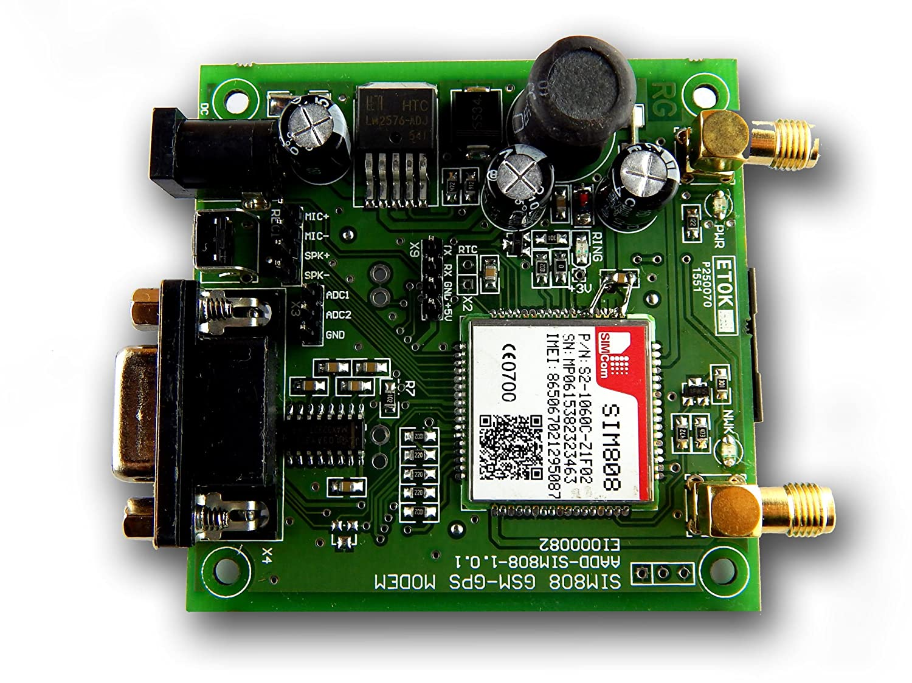

GPS-GSM 808 Module

**-:BME680 Sensor:-**

BME680 is a handy sensor by Bosch. It measures Humidity, Temperature, Pressure and VOC (Volatile Organic Compounds) gas conc. This sensor can also withstand -40 celsius, and so we chose it. Also, the specificity of the sensor is high and the working principle is heating of metal oxides like SnO2.

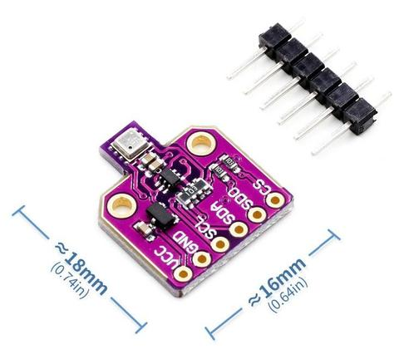

BME680

**-:DSM501A:-**

DSM501A is a dust sensing module which will be used to measure particulate matter concentrations in the air. DSM501A uses a LED lamp for PM monitoring. It can work till -10 celsius. Datasheet : <https://i.publiclab.org/system/images/photos/000/003/726/original/tmp_DSM501A_Dust_Sensor630081629.pdf>

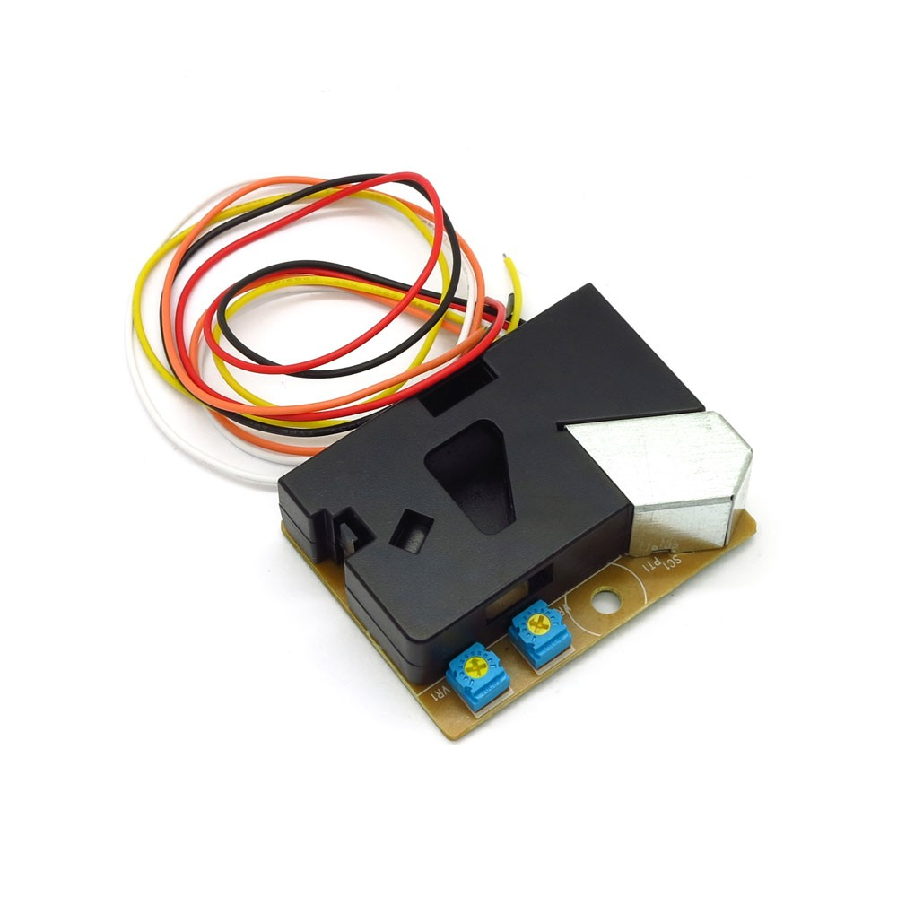

**-:MICS2714:-**

MICS2714 sensor is used for sensing NOx levels in gas. It is a high specificity sensor which works on the principle of heating metal oxide. It can withstand temperatures of -30 celsius. It works on the heated metal oxide principle too. Datasheet: <https://www.cdiweb.com/datasheets/e2v/mics-2714.pdf>

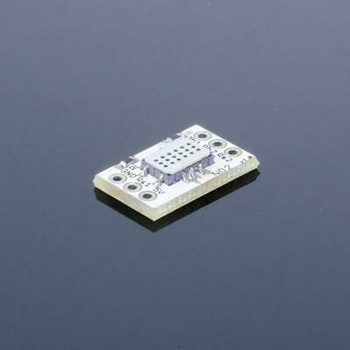

**-:MQ131 Sensor:-**

MQ131 sensor is a sensor for Ozone. It has high specificity for Ozone and low specificity for Cl2 and NO2. It also works on the heated SnO2 principle and can withstand temperatures upto -10 celsius.

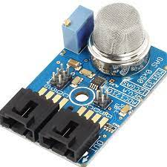

**-:SD Card Module:-**

The SD Card module will be used to store the air quality data in a file in the SD Card.

**-:DC Fan:-**

A DC fan would be used to intake air from surroundings so we don’t have to expose our sensors directly to the environment.

**-:Code and explanations:-**

All the code and explanations (comments) are on the project’s github repository.

This is the code for the BME680 sensor. A serial monitor is intialised in the setup function. The sensitivity of various sensors is set and the heater element temperature has been set.

And then in the loop, the sensor reading is printed on the serial monitor and a delay is added.

The code for ozone monitoring from MQ131.

Code for MICS2714 sensor for NO2.

Particulate matter monitoring by DSM501A

**-:Balloon:-**

We’ll be using a CPR-300 or CPR-350 balloon based on what the final weight of our project is. These balloon sizes will enable us to reach our desired height.

**-:Feasibility in Online mode:-**

There are some roadblocks to this project in the online mode. The sensors we require aren’t present on simulators like tinkercad. The project is quite experimentation heavy (The balloon, the 3d printed box, the calibration of sensors). We have tried to create a pilot simulation of how we would be achieving our project and have created Arduino sketched for the sensors (but they are yet to be tested).

**-:TinkerCAD simulation:-**

As we do not have our original sensors available on tinkercad we have tried a similar circuit using an Arduino UNO with 5 V supply ,a bread board ,and we have used :-

1.Gas Sensor

2.Temperature Sensor[TMP36]

3.LCD controlled by potentiometer to display the temperature and gas concentrations measured by TMP36 and sensor Gas sensor respectively.

4.Buzzer (its operation depend on concentration of gas detected by gas sensor).

5.Three LED’s (red , green and yellow ,at a certain time the color of LED will depend on ,magnitude of temperature measured by TMP36 sensor).

6.A DC Motor (the purpose of including it in our circuit is related to our original project as we are using a DC fan for intake of air to avoid exposure of sensors directly to atmosphere).

**-:Sketch For TINKERCAD circuit:-**

**-:3D model of casing and explanation of design:-**

The final model is a cuboid(170x145x150 mm3).It has two compartments, the upper compartment having inner dimensions 160x135x85 mm3  contains the sensors DSM501A, BME680, MICS2714, MQ131 and the lower compartment having inner dimensions 160x135x50 mm3 has the an Arduino uno, batteries, GPS/GSM module(SIM808) and a breadboard to facilitate all the connections. There is a passthrough mesh between the compartments for the wires from the Arduino/breadboard to connect to the sensors. The upper compartment has a fan for the intake of the air, which will be covered with a mesh to prevent the intake of large dust particles.

**NOTE:-**Assuming the wall width as 5mm.

**-:Reason Behind The Design:-**

The design has been chosen to prevent the sensors from being directly being exposed to the elements of the nature, two compartments were made to prevent the heat from Arduino compartment being lost at high altitudes, and maintain the proper functioning of the Arduino, also it provides a layer of protection from environmental changes. **A computer screen capture
**

Yellow-BME680

Red-MQ131

Green-MISC2714(MIKROE-3700)

Blue-DSM501A

Purple-SIM808

**-:Challenges:-**

1. Battery issue

If the balloon runs out of battery mid-flight, it will stop sending us its location and altitude updates and we won’t be able to track it. We can first have a dry run as to how long does the battery lasts and then can accordingly increase the capacity.

2. concussions and shocks

Sensitivity of sensors can be affected due to concussions or shocks mid-flight. Having a sturdy casing is the solution.

3. Sensor tolerance

We have paid a lot of attention to this part. Still something might go wrong mid-flight. Only experimentation with tethers can help in this case

**-:Further Developments:-**

Integrating all the code files into one and doing a proper physical test of all the sensors, running various tests like battery capacity, concussion test and tethered test, and to see the final working project.

**-:Conclusions:-**

The project upon completion will enable us to monitor air quality of different locations and at different altitudes and this stored data can be used by various agencies for reducing pollution.

We were successful in writing codes for different modules and to create a simple pilot and design the casing. Further work on this project will be done in the offline mode.